MUSHROOM STROGANOFF WITH ASPARAGUS, SPINACH & BROWN RICE

**15 May 2015**

**If you know me well you’ll know I buy more mushrooms than any other vegetable! I’m honestly a little too in love with them, and what they can do to a simple meal. They taste amazing sautéed in a little olive oil, and incredible in a creamy sauce, as in this recipe! Mushroom Stoganoff is a pretty classic recipe, which I’m fully aware doesn’t normally have spinach or asparagus in - but what can I say, the girl likes her greens! The spinach sautés beautifully and adds another dimension to this dish. The sauce is the best part and is made with coconut cream, vegetable bouillon (or stock) and paprika, it’s addictive and so comforting. All in all this recipe is a winner - just picture a lazy night at home snuggled in front of Made in Chelsea (for those of you international this is the TV version of a brownie - a guilty pleasure to the max) with a bowl of brown rice with a steamy, saucy stroganoff! mmm, mmm!**

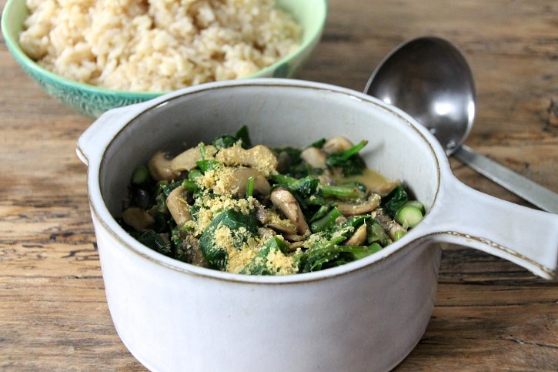

INGREDIENTS

SERVES 2

**2 Punnets of button mushrooms**

**1 Red Onion**

**4 handfuls of spinach**

**A bunch of asparagus**

**1 tablespoon paprika**

**1 clove garlic, crushed**

**1/4 cup coconut cream**

**1/2 cup vegetable bouillon and water (mix 1/2 tsp with 1/2 cup of boiling water)**

**Enough brown rice for two!**

METHOD

**1) Start by washing and pealing the mushrooms and cutting into slices. Then chop up the red onion and asparagus. 2) Add a drizzle of olive oil to your pan and add the red onion, garlic and paprika - sautee until the onion is caramelised and soft. Pour it into a bowl and leave on the side. 3) add the mushrooms and asparagus and sautee until they are both soft - this takes around 8 minutes. 4) Add the stock mixture into a cup and stir in the coconut cream. 5) Pour in the sauce over the vegetable mix and cook until piping hot. 6) Serve over hot brown rice!**

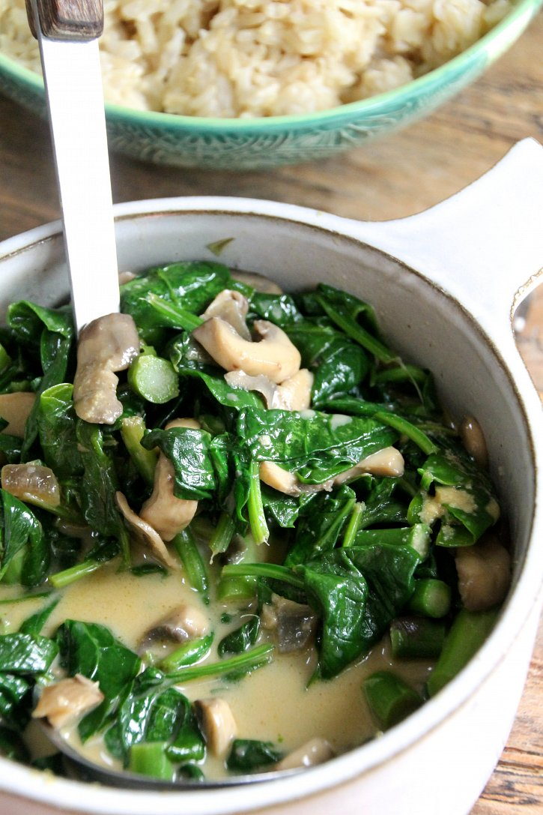

**- See more at: http://www.naturallysassy.co.uk/recipes/mushroom-stroganoff-with-asparagus-spinach-brown-rice#sthash.kUHJtYhq.dpuf**